**“SEGRINATOR”**



**A PROJECT REPORT**

*Submitted by*

|  |  |
| --- | --- |
| **SUNIL KUMAR**  **K NAZIA**  **DIKSHA**  **SHIVANSHH** | **- 19BEM1004**  **- 19BEM1009**  **- 19BEM1026**  **- 19BEM1051** |

***In partial fulfillment for the award of the degree***

***of***

**BACHELOR OF ENGINEERING**

**in**

**MECHATRONICS ENGINEERING**

**Under the Guidance**

**Of**

**Mr. Inderpreet Singh**

**University Institute of Engineering**

**CHANDIGARH UNIVERSITY**

**DECEMBER – 2021**

**CHANDIGARH UNIVERSITY**

**BONAFEDE CERTIFICATE**

Certified that this project report **“SEGRINATOR”**

is the Bonafede work of the following candidates

|  |  |
| --- | --- |
| **SUNIL KUMAR**  **K NAZIA**  **DIKSHA**  **SHIVANSHH** | **- 19BEM1004**  **- 19BEM1009**  **- 19BEM1026**  **- 19BEM1051** |

who carried out the work under my supervision. Certified further that to the best of my knowledge the work reported herein does not form part of any other thesis or dissertation on the basis of which a degree or award was conferred on an earlier occasion on this or any other candidate.

Signature of the Head of the Department Signature of the Supervisor

**SIGNATURE SIGNATURE**

Gurmeet Singh Inderpreet Singh

**HEAD OF THE DEPARTMENT SUPERVISOR**

Lecturer

Department Of Mechatronics’ Department Of Mechatronics’

College Of Engineering College Of Engineering

**CONTENTS**

|  |  |  |
| --- | --- | --- |
| **Sr.No.** | **Content**  **Candidate Declaration**  **Acknowledgement** | **Page no.** |
| 1. | Introduction.............................................................................. | 4 |
| 2. | Literature Survey……………………………………… | 5 |
| 3.  4.  5.  6.  7.  8. | Methodology…………………………………………...   1. Objective 2. Steps Involved   Block Diagram of System……………….......................   1. Description of Parts 2. Application and advantages of system   Approximate Cost and Total Cost……………………..  Workplan……………………………………………...  Workspace…………………………….,…………….  References…………………………………………….. | 6  6-11  11  12  12  13 |

**CERTIFICATE FOR EVALUATION**

**College Name : University Institute of Engineering**

**Branch : Mechatronics Engineering.**

**Year / Semester: III/V**

|  |  |  |  |
| --- | --- | --- | --- |
| **S.NO** | **Name of the Students**  **Who have done**  **the project** | **Title of the project** | **Name of the**  **Supervisor with**  **Designation** |
| **1.** | **SUNIL KUMAR** | **SEGRINATOR** | **Mr. Inderpreet Singh** |
| **2.** | **K NAZIA** |
| **3.** | **DIKSHA** |
| **4.** | **SHIVANSHH** |

The reports of the project work submitted by the above students in partial fulfillment for the award of Bachelor of Engineering degree in Mechatronics Engineering of Chandigarh University were evaluated and confirmed to be the reports of the work done by the above students and then evaluated.

**INTERNAL EXAMINER EXTERNAL EXAMINER**

**ACKNOWLEDGEMENT**

This project, though done by us would not have been possible, without the support of various people, who by their cooperation have helped us in bringing out this project successfully.

We would like to express our faithful thanks to **Mr**. **Inderpreet Singh,** for having extended all the department facilities without slightest hesitation.

We would like to express our unbounded gratefulness to **Mr**. **Inderpreet Singh** for their valuable guidance and encouragement throughout the project.

We thank all faculty members and supporting staff for the help they extended to us for the completion of this project.

**INTRODUCTION**

Currently, garbage disposals have become quite problematic as segregating waste into various categories is also important. There are few who are knowledgeable in such related concepts but are quite lazy to do so, while there are also few who are clueless in such matters. With advancing technologies, the demand for smart homes is quite high, and as such the smart segregation concept comes to play an important role. Nobody wants to live in a messy or unhygienic place.

The garbage problem does not only lie in homes but also in the environment. We can hear some news regarding uncontrolled waste dumping on the corner of a neighbourhood, or it could be the garbage accumulated on the beaches. Though there is active environmentalist helping clean out such places the problem all the more stops at segregating, waste separation is an important concept that cannot be overlooked as some are bio-degradable while some aren’t, some can be recycled and some cannot. Leaving them unattended can be harmful which is toxic to the environment. It could also lead to health problems such as asthma, cancer, infectious disease, and many more.

**Literature Survey**

This project cites to present a brief preview of some of research work performed in the area of Smart-Segregation.

The team discussion started from the topic of easy waste disposal with waste separation which is also automatic.

After finalizing the topic, we researched on various topics related to waste disposal, and automatic waste management and concluded to make a smart dustbin that can be used both in public places and at home.

After finalizing the idea, the following first week, we ordered our components, and started designing a durable dustbin, so as to make it small enough to fit even in home.

After finalizing the design, while along with researching more. After a few days, we finalized the components to be used and ordered them.

**Methodology**

1. **Objective:**

* The main objective is to provide proper waste disposal and waste management.
* The use of various sensors such as Inductive proximity sensor, touch sensor, moisture sensor and IR sensor.
* Use of Arduino, the microcontroller, with above sensors and servo motors.

1. **Procedure:**

* Firstly, we decide on the process/working the based on that we check the components needed.
* The following components are needed.

|  |  |
| --- | --- |
| * Arduino UNO R3 * Micro Servomotor * Metal Servomotor * Jumper Wires * Breadboard | * Inductive Proximity Sensor * Soil Moisture Sensor * Touch Sensor * IR Sensor * Three Bins (to store waste) |

* Then the following connections are made on the Arduino.

|  |  |  |
| --- | --- | --- |
| Component Name | Arduino attached Pin No. |  |
| * Micro Servomotor | D8 |  |
| * Metal Servomotor | D9 |  |
| * Inductive Proximity Sensor | D11 |  |
| * Soil Moisture Sensor | D2 & D7 |  |
| * Touch Sensor | D12 | D- Digital |
| * IR Sensor | A2 | A- Analog |

1. **Block Diagram:**

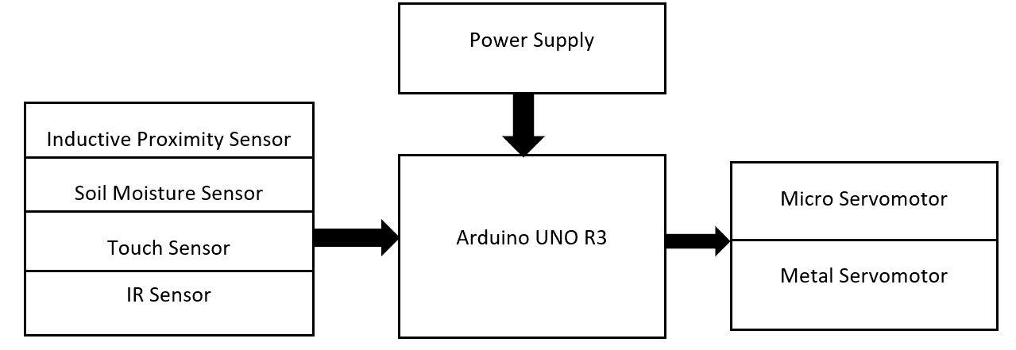

1. **Description of Parts:**

|  |
| --- |
| Arduino UNO R3 is the heart of this project, it is an ATmega328P based microcontroller that includes all the components needed to hold a microcontroller, we attach it to PC using an USB cable, and using Arduino IDE, we can easily configure this program controller. |
| Micro Servo Motor SG90 is a tiny and lightweight server motor with high output power. It can approximately rotate up to 180 degrees (90 in each direction), and works just like the standard kinds but smaller. |
| Tower Pro MG995 Metal Gear Servo Motor (180 Degree Rotation) from ElectronicsComp.com  MG995 Metal Gear Servo Motor is a high-speed standard servo rotating approximately 180 degrees (60 in each direction). It is a Digital Servo Motor which receives and processes PWM signal faster and better. |
| Tube Type Inductive Proximity Sensor Detection Switch NPN DC6-36V 4mm Normally Open switch LJ12A3-4-Z/BX | Robu.in  Inductive Proximity Sensors detects magnetic loss due to eddy currents that are generated on a conductive surface by an external magnetic field. On the detection coil, an AC magnetic field is generated, and changes in the impedance due to eddy currents generated on a metallic object are detected. |
| TTP223 - 1 Channel Capacitive Touch Sensor Module Blue Color from ElectronicsComp.com  A touch sensor is a device that captures and records physical touch or embrace on a device and/or object. It enables the device or object to detect touch or near proximity, typically by a human user or an operator. They are also called as tactile sensors and also, they are sensitive to touch, force or pressure. |

1. **Circuit Diagram:**

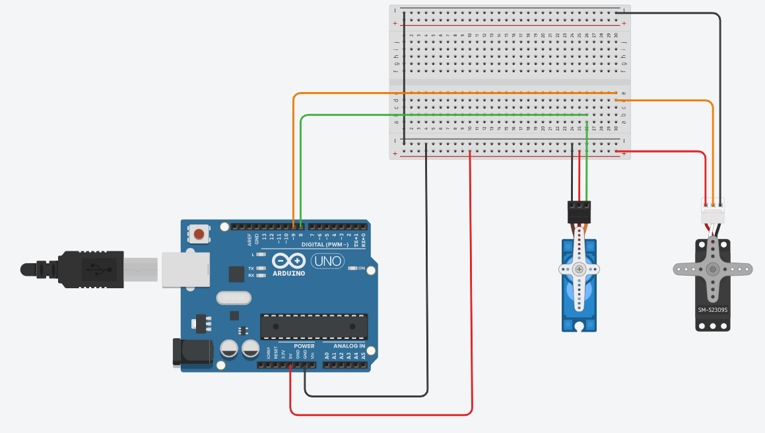For Servomotors

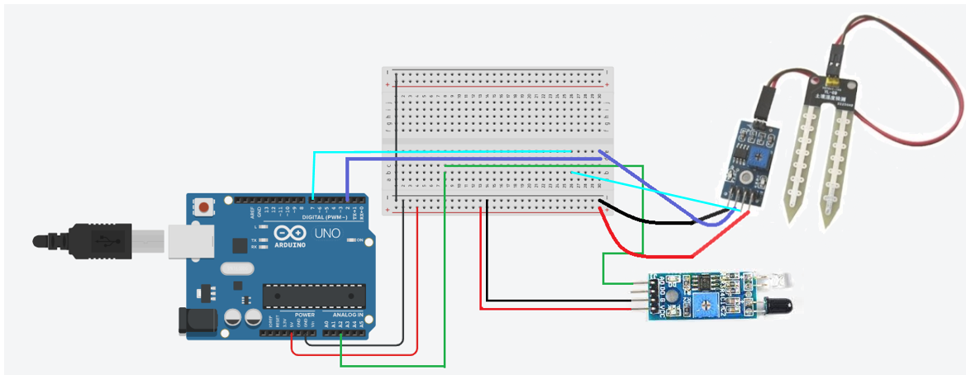For Moisture sensor and IR sensor

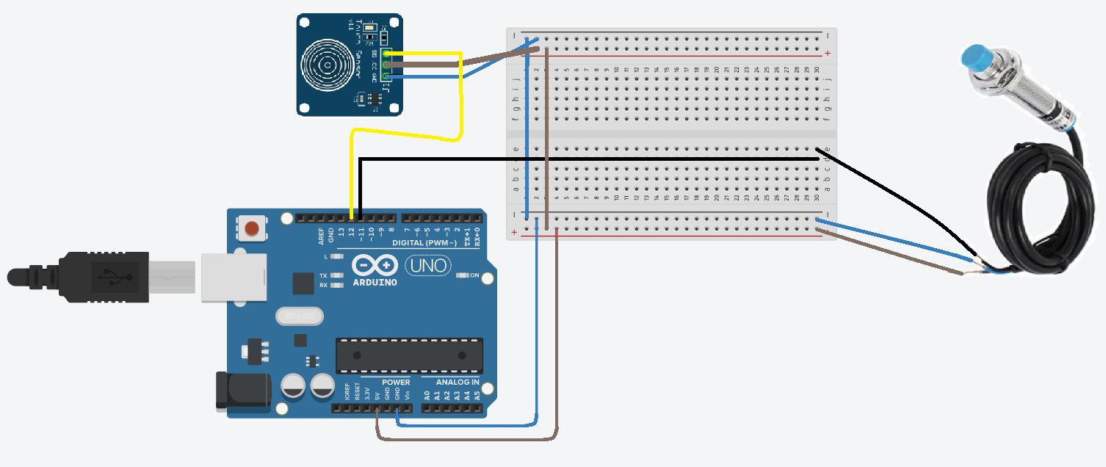For Inductive Proximity Sensor and Touch sensor

|  |  |  |  |
| --- | --- | --- | --- |
| **WASTE** | **Metal-Bin** | **Wet- Bin** | **Dry- Bin** |
| **Nail** | YES | - | - |
| **Wet tissue** | - | YES | - |
| **Paper** | - | - | YES |
| **pen** | YES | - | - |
| **Matchbox** | - | - | YES |

**Applications and Advantages of System:**

* Smart Segregation.
* Hygiene, safety and health benefits.
* Inexpensive and time saving in waste management.
* Easy to handle.
* Reduced waste and recycled waste
* Reduces environment pollution
* Reduced space consumption of landfills

|  |  |  |  |
| --- | --- | --- | --- |
| **Sr. No** | **Items** | **Qty** | **Cost (Rs)** |
| 01 | Arduino UNO R3 | 1 | 770 |
| 02 | Micro Servomotor | 1 | 200 |
| 03 | Metal Servomotor | 1 | 350 |
| 04 | Inductive Proximity Sensor | 1 | 700 |
| 05 | Soil Moisture Sensor | 1 | 160 |
| 06 | Touch Sensor | 1 | 100 |
| 07 | IR Sensor | 1 | 170 |
| 08 | Bins | 3 | 60 |
| 09 | Jumper Wires |  | 20 |
| 10 | Breadboard | 1 | 200 |
| 11 | Wood |  | 200 |
| 12 | Nuts and bolts |  | 60 |
|  | Total |  | 2990 |

**Workplan:**

|  |  |  |  |  |
| --- | --- | --- | --- | --- |
|  | **August** | **September** | **October** | **November** |
| Week 1 | Research on Project Idea | Discussion on model design | Components ordered | Coding the Arduino. |
| Week 2 | Research on the chosen project | Completed model design | ----- | Segrinator is completed |
| Week 3 | ---- | Start of Research Paper making | Components arrived | Completed Research Paper |
| Week 4 | Finalize the project | Start of Synopsis Report making | Connection and sample test complete | Completed Synopsis report |

1. **Workspace:** we have distributed our work in the following manner:

|  |  |
| --- | --- |
| **Work done by Sunil Kumar**   * Physical Modelling * Circuit Connection * Synopsis Report | **Work done by Diksha**   * Project Design * Project Presentation * Research Paper |
| **Work done by Nazia**   * Research Paper * Coding * Project Presentation | **Work done by Shivanshh**   * Physical Modelling * Circuit Connection * Synopsis Report |

**References**

[1] P. R. NO, ‘WASTE SEGREGATION USING SMART DUSTBIN PROJECT REFERENCE NO .: 40S _ BE _ 0621 INTRODUCTION : OBJECTIVES ’:

[2] I. P. SENSOR, ‘AUTOMATIC WASTE SEGREGATOR PROJECT REFERENCE NO : 38S012 8’.

[3] ‘SENSOR BASED SMART DUSTBIN FOR WASTE SEGREGATION AND STATUS ALERT’, NO. 5, PP. 98–103, 2017.

[4] G. Aahash, V. A. Prasath, D. Gopinath, M. G. Electronics, and C. Engineering, ‘Automatic Waste Segregator using Arduino’, vol. 6, no. 07, pp. 6–8, 2018.

[5] N. S. Gupta, V. Deepthi, M. Kunnath, P. S. Rejeth, T. S. Badsha, and B. C. Nikhil, ‘Automatic Waste Segregation’, 2018 Second International Conference on Intelligent Computing and Control Systems (ICICCS), no. September 2020, pp. 1688–1692, 2018, doi: 10.1109/ICCONS.2018.8663148.

[6] C. Agarwal, ‘Automatic Waste Segregation and Management’, vol. 9, no. 06, pp. 715–718, 2020.

[7]‘AUTOMATED WASTE SEGREGATION MACHINE’, vol. 8, no. 9, pp. 3068–3080, 2020.

[8] M. Pandey, A. Gowala, M. Goswami, and C. Saikia, ‘Smart dustbin using arduino’, no. August, 2020.

[9] E. Malleswari and S. N. Kishore, ‘Smart Wastage Segregation using Arduino UNO’, no. 5, pp. 2074–2078, 2020, doi: 10.35940/ijrte.E5734.018520.

[10] J. Dileep, S. N. A. Ashitha, and S. N. Thoshitha, ‘Smart Waste Segregation using Arduino Uno’, vol. 8, no. 8, pp. 472–475, 2021, doi: 10.17148/IARJSET.2021.8878.

**Process Flowchart**

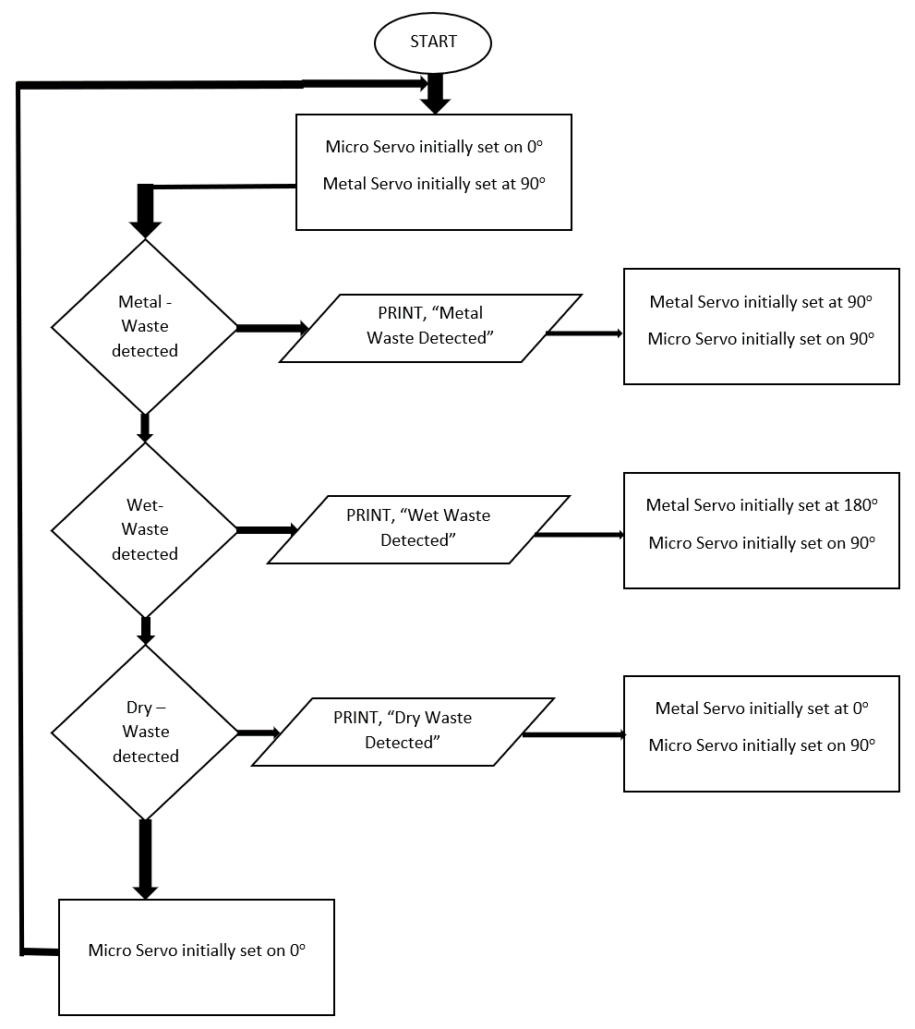

**Code used:**

#include<Servo.h>

Servo servo1; //micro servomotor

Servo servo2; //metal servomotor

// Sensor pins

#define sensorPower 7 //moisture sensor output

#define sensorPin 2 //moisture sensor input

#define me_pin 11 //metal sensor input

#define t_pin 12 //touch sensor input

#define ir_pin A2 // IR sensor input

int d_ir=0;

int d_me=0;

int d_t=LOW;

void setup()

{

pinMode(sensorPower, OUTPUT); // setting pin mode

// Initially keep the sensor OFF

digitalWrite(sensorPower, LOW); //Initializing pin status

servo1.attach(8); //microservo attached to pin 8

servo2.attach(9); //metalservo attached to pin 9

pinMode(me_pin,INPUT); // setting pin mode

pinMode(t_pin,INPUT); // setting pin mode

pinMode (ir_pin, INPUT); // setting pin mode

Serial.println("Smart Segregator ready");

Serial.begin(9600);

}

void loop()

{

servo2.write(90); //metal servo positioned initially to 90 degree

delay(500); //delay of 1/2 second

servo1.write(0); //micro servo is closed

//get the reading of INDUCTIVE PROXIMITY SENSOR

d_me=digitalRead(me_pin);

delay(15);

//get the reading of TOUCH SENSOR

d_t=digitalRead(t_pin);

delay(15);

//get the reading of IR SENSOR from the below function

d_ir = readIR();

Serial.print("Digital Output IR: ");

Serial.println(d_ir);

delay(15);

//get the reading from the function below and print it

int val = readSensor();

Serial.print("Digital Output Moisture: ");

Serial.println(val);

delay(15);

//--------------------WASTE SEGREGATION--------------------

//checks for metal waste or wet waste or dry waste

if(d_me!=0)

{

Serial.println("Metal waste detected");

servo2.write(90);

delay(1000);

servo1.write(90);

delay(1500);

}

else if(val==0 && d_me==0 && d_t==HIGH)

{

Serial.println("Wet waste detected");

servo2.write(180);

delay(1000);

servo1.write(90);

delay(1500);

}

else if(val==1 && d_me==0 && d_ir==1)

{

Serial.println("Dry waste detected");

servo2.write(0);

delay(1000);

servo1.write(90);

delay(1500);

}

else

{

servo1.write(0);

}

delay(1000);

Serial.println();

}

//This function check the input of IR sensor

int readIR()

{

int ir=digitalRead(ir_pin);

if(ir==1)

{

digitalWrite(LED, LOW);

return 0;

}

else

{

return 1;

digitalWrite(LED, HIGH);

}

}

// This function returns the analog soil moisture measurement

int readSensor()

{

digitalWrite(sensorPower, HIGH); // Turn the sensor ON

delay(10); // Allow power to settle

int val = digitalRead(sensorPin); // Read the analog value form sensor

digitalWrite(sensorPower, LOW); // Turn the sensor OFF

return val; // Return analog moisture value

}